Yorktown Movers

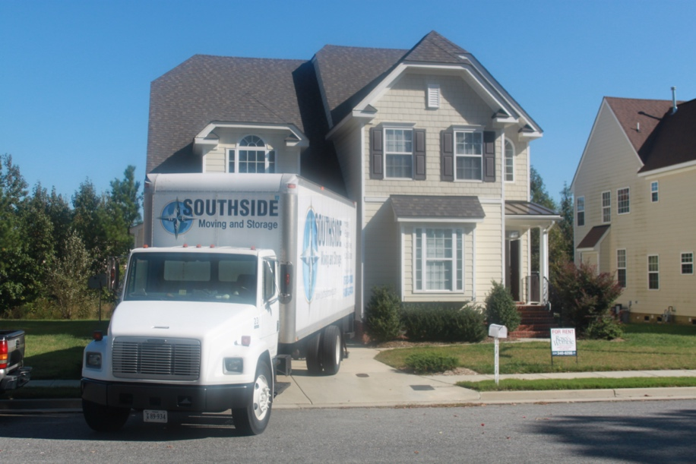

Yorktown Movers 757-234-7080

Moving Company in York County, VA

If you’re moving anywhere in Hampton Roads, including Yorktown, Southside Moving and Storage can provide all the moving services you’re looking for. Our York County Movers have been providing both residential and commercial moving and storage services for years. Our professional movers specialize in Local Moving, Long Distance Moving, Commercial Moving and International Moving. Southside Moving and Storage provides professional moving services for both commercial and residential relocations. Whether you are moving from a house, apartment, business, or dorm, Southside Moving and Storage is here in York County, VA to help you.

In addition to professional moving services, our [**York County Moving Company**](http://southsidemoving.com) also offer a full line of packing supplies, valuation protection, professional moving blankets, storage, and anything else you may need to make your transition to your new home as stress-free as possible.

Southside Moving and Storage is fully licensed and insured, operating a state-of-the-art fleet of trucks ensuring a safe and smooth ride for your household Goods. Our [**Yorktown Movers**](http://southsidemoving.com) highly-trained relocation teams provide affordable, reliable moving services across the country or around the Hampton Roads area. Whether you’re moving to Yorktown or moving from Yorktown, you can count on us.

**Southside Moving and Storage Offers:**

* Competitive Pricing
* Full Time, Professional Trained and Certified Moving Crews
* Experienced Relocation Specialists
* Replacement Protection
* Free In Home Moving Estimates
* Free Box Kits
* Local and Long Distance Moving Services
* Packing Services

